**CI CD project**

Prepared by: Gina Emil Attia Baky

https://github.com/gina413/Booster_CI_CD_Project

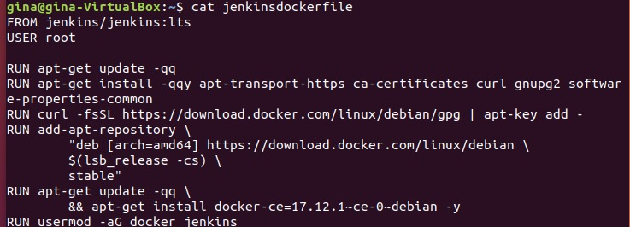

* 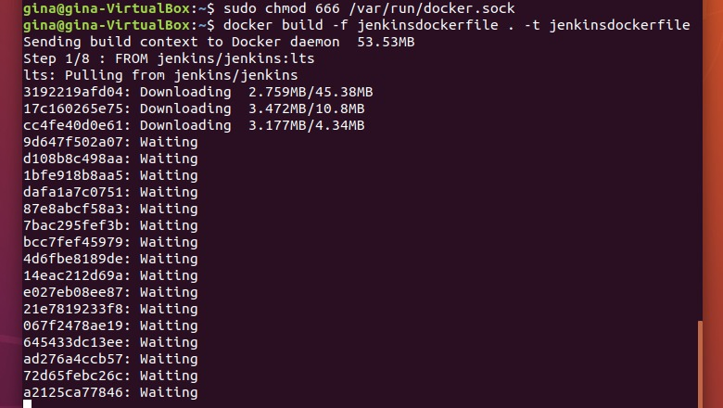Docker file for the master
* Build the master image

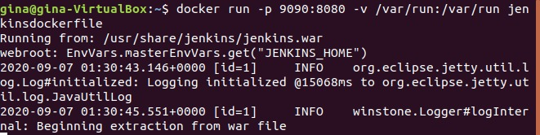

* Run the master



* 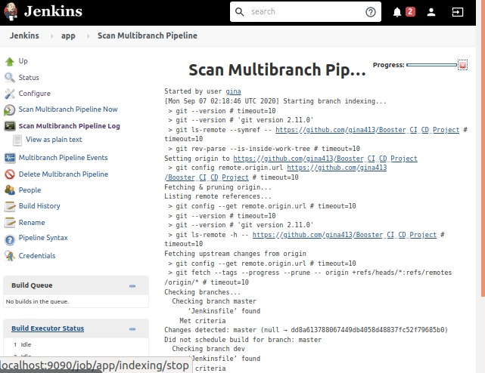Build the slave image

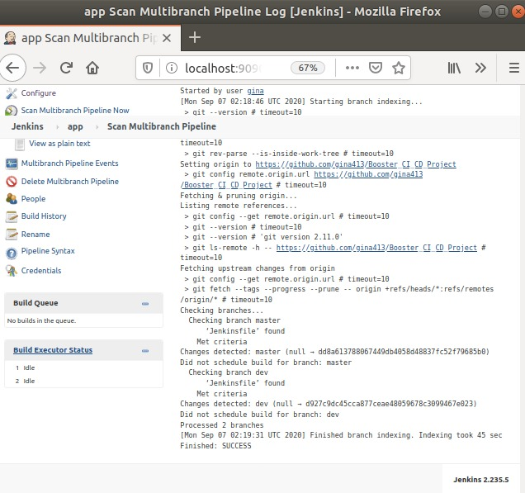

* Multibranch pipeline log

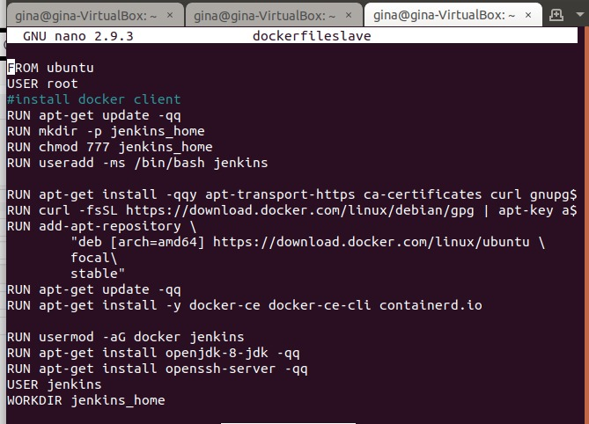

* Docker file for the slave
* Run the slave
* Start ssh services
* 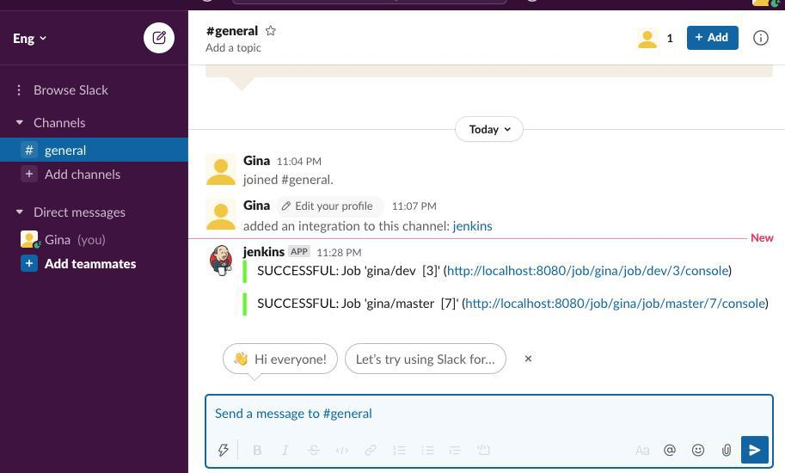Generate the private and public key
* Run, deploy, push using Jenkins
* Receive notification on slack